COLOUR SELECTION FORM – FULLY LOADED INCLUSIONS

JOB ADDRESS

JOB NUMBER
Date
Client
Colour Consultant |  | Helen Brown - LivingSpaces
Contact |  | helen@livingspaces.com.au – 0406 544 702

EXTERNAL FINISHES

ITEM | SPECIFICATION |  |  | UPGRADE | NOTES
ROOF
Roof |  | Metal Sheet, Colorbond Custom Orb, Colour –
Gutter |  | Colorbond 150mm Quad Colorbond
Fascia |  | Colorbond

BRICKS
Bricks | PGH Bricks -
Mortar |  |  | Off white
Joint

CLADDING
Cladding Type
Stone | Craftstone
Cultured Stone Grout | Grouted, Natural Grout/ Dry stacked

ITEM | SPECIFICATION |  | UPGRADE | NOTES
ALUMINIUM WINDOWS, DOORS & SCREENS
Window & Sliding Door Frames
Glazing |  | Clear, obscure to wet areas
Fly Screens – Frame colour
Security Screens – Frame colour
Security Screens – Grille |  |  | invisiguard

EXTERNAL DOORS
Garage Door Type | Panel sectional door, profile –
Garage Door Colour
Front Entrance Door | / 1200w -XS - , Painted / Stained finish  Glazing -
Front Entrance Door Hardware | Gainsborough Trilock 890  Bright Chrome/ Satin Chrome
Other External Door | Or Flush panel solid door, paint finish
Other External Door Hardware | Gainsborough Govenor 840  Bright Chrome/ Satin Chrome

EXTERNAL PAINTING
WALLS
Main Render Colour
Feature Render Colour
Cladding
FC Sheeting – above garage
FC Sheeting – above bricks
DOORS & WINDOWS
Front Entrance Door
Other External Door
Garage Door Jamb
Hamptons Window Frames
CEILINGS
Eaves, Porch & Alfresco ceilings
EXTERNAL TRIMS
Timber Posts
Downpipes | To match wall behind. If on bricks -
GABLES
Gable FC backing
Gable Timbers
Finials
EXTERNAL STAIRS
Balustrades
Handrails
Treads & Risers

EXTERNAL FLOORING
Porch | Tiled
Alfresco
Veranda

 |  | DRIVEWAY
Driveway & path |  |  | Exposed aggregate

 |  | EXTERNAL FIXTURES
Letterbox | Polytek - , colour -
Clothesline | colour -
Water tank | Polytank -

 |  | SHED
Roof | Colorbond
Gutter | Colorbond
Walls | Colorbond
Roller Door | Colorbond
Personal Door | Colorbond
Windows

INTERNAL FINISHES

ITEM | SPECIFICATION |  | UPGRADE | NOTES
INTERNAL DOORS & HARDWARE
Internal Doors |  | Flush panel doors, paint finish
Internal Door Hardware |  | Gainsborough leverset, type –  Bright Chrome/ Satin Chrome  Privacy locks to bathroom, ensuite, WC & master bedroom
Cavity Slider Door Hardware |  | Gainsborough Round,  Bright Chrome/ Satin Chrome
Sliding Wardrobe Doors |  | Frame – Bright/ Satin chrome  Panels – Vinyl | Mirrors

SKIRTINGS & ARCHITRAVES
Skirting | 67mm x 11mm -
Gutter | 42mm x 11mm -
Cornice

INTERNAL STAIRS
Treads | Durian timber
Risers | Enclosed risers, Durian timber,
Handrail | Durian timber
Balustrade

TILING
Main Floor Tile | Tile City  with Light Grey/ Mid Grey  , Matt finish
 |  | EXTERNAL FLOOR TILES
Porch Tile | Tile City  with Light Grey/ Mid Grey  , Matt / External Finish
Alfresco Tile
 |  | MAIN BATHROOM TILES
Main Bathroom Floor Tile | Tile City  with Light Grey/ Mid Grey  , Matt finish
Main Bathroom Wall Tile | Tile City 200 x 400 Gloss white with  Laid Horizontally/ Vertically  in pattern
Main Bathroom Feature Tile
Main Bathroom Feature Tile Location

ITEM | SPECIFICATION |  |  | UPGRADE | NOTES
 |  |  | MAIN BATHROOM (cont.)
Main Bathroom Skirting Tile |  | Wall/ Floor tile
Main Bathroom Bath Hob Tile |  | Wall/ Floor tile
 |  |  | ENSUITE
Ensuite Floor Tile |  | Tile City  with Light Grey/ Mid Grey  , Matt finish
Ensuite Wall Tile |  | Tile City 200 x 400 Gloss white with  Laid Horizontally/ Vertically  in pattern
Ensuite Feature Tile
Ensuite Feature Tile Location
Ensuite Skirting Tile |  | Wall/ Floor tile
 |  |  | WC/ POWDER ROOM
WC Floor Tile |  | Tile City  with Light Grey/ Mid Grey  , Matt finish
WC Splashback tile |  | Tile City 200 x 400 Gloss white with  Laid Horizontally/ Vertically  in pattern
WC Skirting tile |  | Wall/ Floor tile
 |  |  | LAUNDRY
Laundry Floor Tile |  | Tile City  with Light Grey/ Mid Grey  , Matt finish
Laundry Splashback tile |  | Tile City 200 x 400 Gloss white with  Laid Horizontally/ Vertically  in pattern
Laundry Skirting tile |  | Wall/ Floor tile
 |  |  | KITCHEN
Kitchen Splashback Tile |  | Tile City 200 x 400 Gloss white with  Laid Horizontally/ Vertically  in pattern
Butlers Pantry Splashback Tile |  | Tile City 200 x 400 Gloss white with  Laid Horizontally/ Vertically  in pattern

ITEM | SPECIFICATION |  |  | UPGRADE | NOTES
 |  |  | CABINETRY
 |  |  | KITCHEN
Benchtop |  | benchtop with Aris edge  Colour -
Lower Cabinets |  | Polytec Melamine –
Overhead Cabinets |  | Polytec Melamine –
Island Bench Cabinets |  | Polytec Melamine –
Fridge Panel & Overheads |  | Polytec Melamine –
Handles - Lowers |  | Horizontal/ Vertical
Handles - Overheads |  | Horizontal/ Vertical
 |  |  | BUTLERS PANTRY
Benchtop |  | benchtop with Aris edge  Colour -
Lower Cabinets |  | Polytec Melamine –
Overhead Cabinets |  | Polytec Melamine –
Island Bench Cabinets |  | Polytec Melamine –
Fridge Panel & Overheads |  | Polytec Melamine –
Handles - Lowers |  | Horizontal/ Vertical
Handles - Overheads |  | Horizontal/ Vertical
 |  |  | MAIN BATHROOM
Benchtop |  | benchtop with Aris edge  Colour -
Cabinets |  | Polytec Melamine –
Handles |  | Horizontal/ Vertical
 |  |  | ENSUITE
Benchtop |  | benchtop with Aris edge  Colour -
Cabinets |  | Polytec Melamine –
Handles |  | Horizontal/ Vertical
 |  |  | POWDER ROOM
Benchtop |  | benchtop with Aris edge  Colour -
Cabinets |  | Polytec Melamine –
Handles |  | Horizontal/ Vertical
 |  |  | LAUNDRY
Benchtop |  | benchtop with Aris edge  Colour -
Cabinets |  | Polytec Melamine –
Handles |  | Horizontal/ Vertical

FLOORING
Main floor vinyl
Carpet

ITEM | SPECIFICATION |  |  | UPGRADE | NOTES
INTERNAL PAINTING
Back of Front Door |  | Wattyl -
Main Wall Colour |  | Wattyl -
Feature Wall Colour |  | Wattyl
Feature Wall Location
Internal Doors |  | Wattyl –  Acrylic, Gloss finish
Skirtings & Architraves |  | Wattyl –  Acrylic, Gloss finish
Ceilings |  | Wattyl –  Matt finish
FIXTURES AND FITTINGS
MAIN BATHROOM
Shower Screen |  | Standard Framed,  Bright/ Satin Chrome
Mirror |  | Frameless
Shower Type |  | Vertical Rose & Rail/ Ceiling Rose
Tile Trim Colour |  | Bright Chrome
 |  |  | ENSUITE
Shower Screen |  | Standard Framed,  Bright/ Satin Chrome
Mirror |  | Frameless
Shower Type |  | Vertical Rose & Rail/ Ceiling Rose
Tile Trim Colour |  | Bright Chrome
 |  |  | POWDER ROOM
Mirror |  | Frameless

STANDARD SPECIFICATION
ITEM | SPECIFICATION |  | IMAGE
TAPWARE
Kitchen / Pantry Mixer |  | Mizu Sooth Sink Mixer 9504417, Chrome | 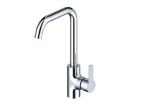
Basin Tapware |  | Mizu Sooth Basin Mixer 9503817, Chrome | 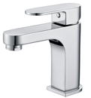
Shower/ Bath mixer |  | Mizu Sooth Shower/ Wall Mixer 9503819, Chrome | 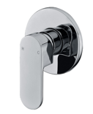
Shower |  | Mizu Drift 200mm Ceiling Rose - Chrome 9505038  OR Posh Domaine Rail shower, 3 Function - Chrome 2213359 | 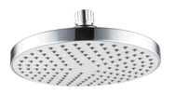  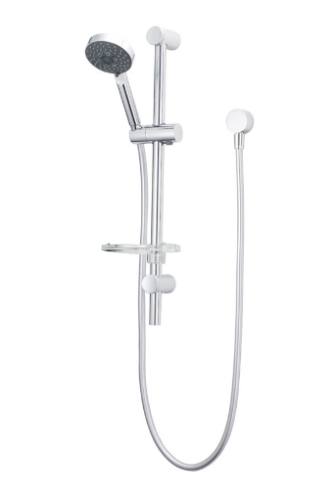
Bath Spout |  | Mizu Soothe Fixed Outlet  OR Posh Solus Swivel Outlet 9506148 Chrome | 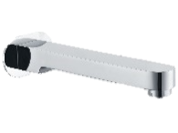  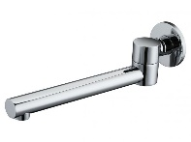
Laundry Mixer |  | Porcha Sink Mixer 9505249 – Chrome | 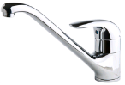
APPLIANCES
Freestanding Oven and Cooktop |  | Westinghouse 900 Freestanding Stove WFE914SB (Stainless Steel Electric Oven/ Gas Cooktop)  OR Westinghouse 900 Freestanding Stove Stainless Steel Electric Oven/ Electric Cooktop | 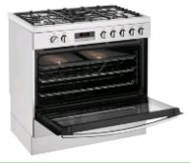
Rangehood |  | Westinghouse 900 Canopy WRF900CS  OR Electrolux 900mm 2 speed twin fan rangehood (ERR927SA) | 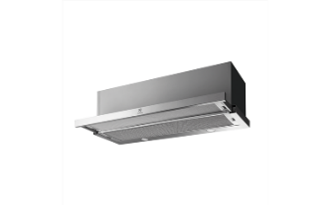  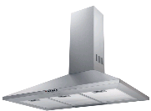
Dishwasher |  | Westinghouse WSF6602XA 60cm dishwasher | 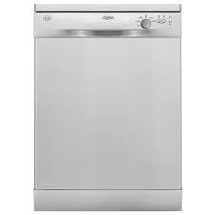
PLUMBING PC’S
Kitchen sink |  | Base MKII Double Bowl Stainless Steel Drop in Sink | 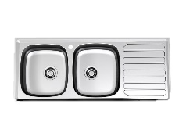
Pantry Sink |  | Mizu Round Stainless Steel Drop in Sink | 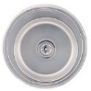
Bath |  | Base White Acrylic bath - size as per plan  Chrome waste | 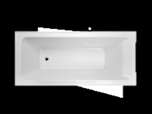
Vanity Basin |  | Roca Diverter Semi Recessed Basin - White with one tap hole  OR Posh Domaine Above Counter Overflow basin 1 taphole - 9509022  (20mm stone top with no apron front)  Chrome plated pop up waste | 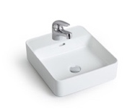  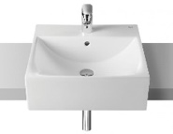
Toilet |  | Posh Stylus Close Coupled Back to Wall Suite | 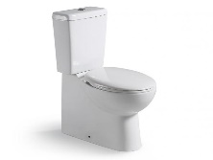
Laundry sink |  | 45L drop in tub with melamine cabinetry as per plan (2000365)  OR 45L Tub with cabinet OR 45L drop in tub with melamine cabinetry (as per plan) | 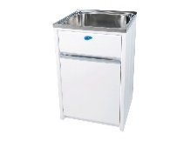  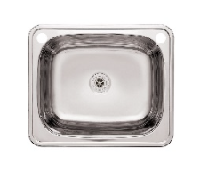
ACCESSORIES
Towel Rails |  | Mizu Soothe Double Towel Rail, 750mm Chrome
Toilet Roll Holder |  | Mizu Soothe Toilet Roll Holder, Chrome | 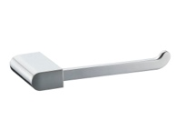
Floor Waste

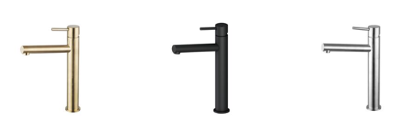
UPGRADE OPTIONS
ITEM | SPECIFICATION |  | IMAGE
TAPWARE
Kitchen / Pantry / Laundry Mixer |  | Mizu Sooth Pull Down Spray Mixer, 9505297, Chrome | 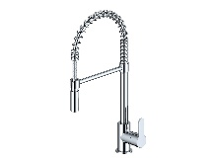
Kitchen / Pantry/ Laundry Mixer |  | Mizu Drift MK2 Gooseneck Sink Mixer Tap  Matte Black 9509133 / Brushed Nickel 9509141 / Brushed Gold 9509148 | 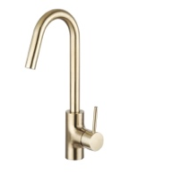  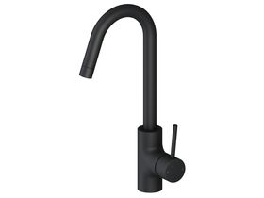  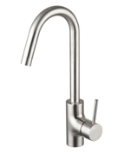
Kitchen / Pantry/ Laundry Mixer |  | Mizu Drift MK2 Gooseneck Pull Out Sink Mixer  Matte Black 9509134/ Brushed Nickel 2219407 / Brushed Gold 2219409 | 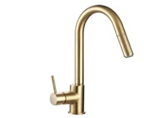  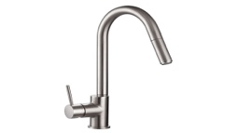  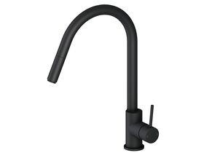
Basin Mixer |  | Mizu Sooth Extended basin mixer chrome – 9508727 - | 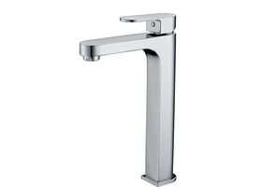
Basin / Bath Mixer |  | Mizu Sooth Wall basin Mixer Tap set 200mm, chrome - 9505295 | 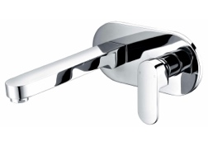
Basin Mixer – Colours |  | Mizu Drift MK2 Basin Mixer – Matt Black/ Brushed Nickel/ Brushed Gold  (to be used with standard basins) | 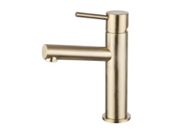  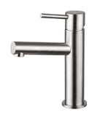  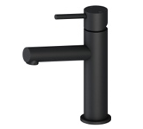
Extended Basin Mixer |  | Mizu Drift MK2 Extended Basin Mixer  Matt Black/ Brushed Nickel/ Brushed Gold
Wall Basin mixer |  | Mizu Drift MK2 Wall Basin Mixer Tap Matt Black/ Brushed Nickel/ Brushed Gold | 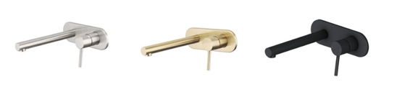
Shower Mixer |  | Mizu Drift Mk2 shower mixer  Matt black/ Brushed Nickel/ Brushed Gold | 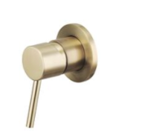
Twin Shower |  | Posh Domaine Twin shower rail shower  Available in Chrome, Matt Black, Brushed Nickel, Brushed Gold
Vertical Rose and Rail |  | Posh Domain Rail shower  Matt Black/ Brushed Nickel/ Brushed Gold
Ceiling Shower |  | Mizu Drift Overhead 200mm or 300mm in Matt Black/ Brushed Nickel/ Brushed Gold | 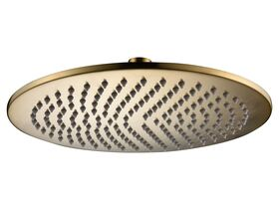  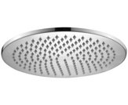  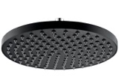
Bath Spout |  | Mizu Drift Curved Bath Outlet 250mm  Matt Black/ Brushed Nickel/ Brushed Gold | 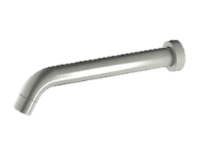  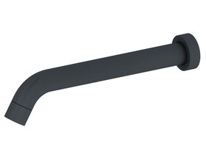  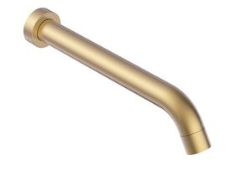
Floor Mounted Bath Spout |  | Mizu Drift MK2 Floor Mounted Bath Outlet  Matt Black/ Brushed Nickel/ Brushed Gold | 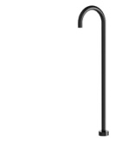
PLUMBING PC’S
Kitchen Sink |  | AFA Flow double undermount sink - 2000396 | 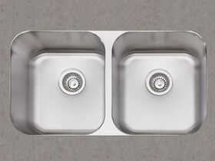
Kitchen Sink |  | Franke Impact Granite IMG120-35 Double Bowl Undermount Sink Onyx | 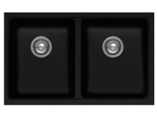
Kitchen Sink |  | Franke Impact Granite Reversible Double Bowl Sink Only with Drainer Reversible No Taphole Black Onyx | 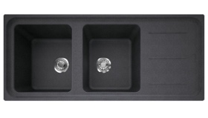
Kitchen Sink/ Laundry |  | Franke Impact Granite IMG110-50 Single Bowl Undermount Sink Onyx
Kitchen Sink |  | Memo Harper 1 3/4 Bowl Butler Sink Fireclay | 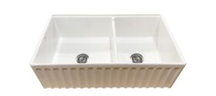
Kitchen sink |  | Memo Harper Single Bowl Butler Sink Fireclay | 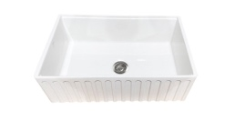
Kitchen Sink |  | Memo Harper Single Bowl Inset/Undermount Sink 598mm Fireclay White – Chrome waste | 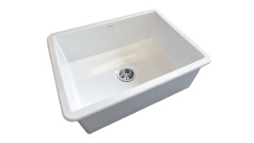
Kitchen Sink |  | Memo Harper Single Bowl Inset/Undermount Sink 462mm Fireclay White – chrome waste | 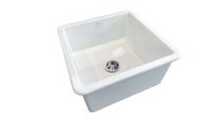
Freestanding Bath |  | Freestanding bath - option 1  Base Freestanding bath 200L  1560 x750 - 9504428  OR Freestanding bath - option 2  Base Freedstanding bath 250L  1760 x 800 x 590 - 9504384
Vanity Basin |  | American Standard Cygnet Vessell Basin no tap hole, white - 9506461  (requires either extended basin mixer OR wall basin mixer)  20mm stone top, no apron front  Chrome, Matt Black, Brushed Nickel or Brushed Gold pop up waste | 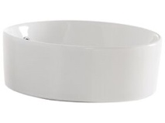
Vanity Basin |  | Roca Inspira Soft Vessel Basin, no tap hole 370 Round - 9507158 -  (requires either extended basin mixer - OR wall basin mixer )  20mm stone top, no apron front  White, Chrome, Matt Black, Brushed Nickel, Brushed Gold pop up waste | 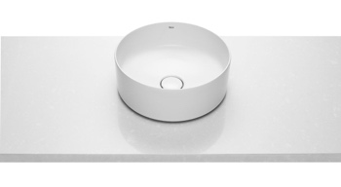
Vanity Basin |  | Roca Inspira Soft Vessel Basin No taphole, 370mm white - 9507161  (requires either extended basin mixer OR wall basin mixer)  20mm stone top, no apron front  White, Chrome, Matt Black, Brushed Nickel, Brushed Gold pop up waste | 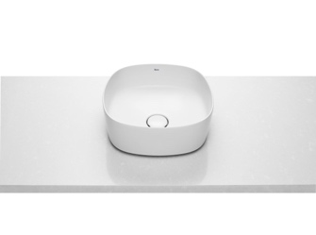
NOTES:

